Exhibit A

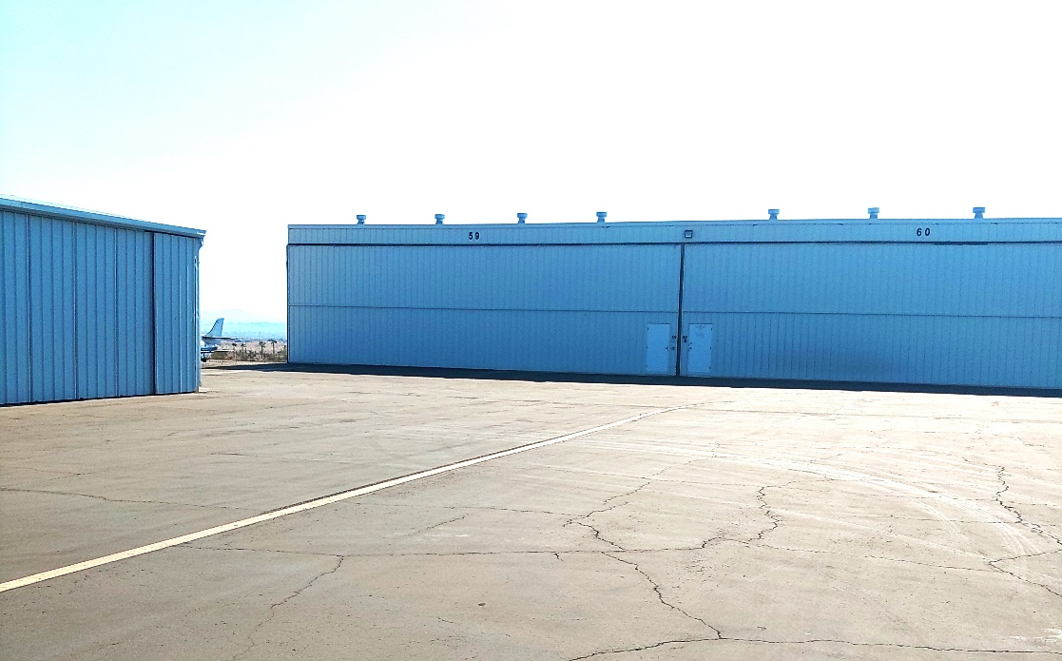

Hangar location and proximity to Runway 14/32